***Buyer Journey and Content Marketing Framework (CMF) Review***

**Overview**

Understanding the buyer’s journey is an important step in working toward the Content Marketing Framework and ultimately the Content Marketing Calendar in the Tactical Phase of Marketing. We must understand the different steps or phases prospects go through in making a decision so that we can provide all the necessary information to guide them through the process and toward us. Further, understanding how long this cycle lasts, whether days, months or years is also important and dictates how much information we need to provide over time.

The formula in the process looks like this:

***Buyer Personas + Buying Journey = Content Marketing Framework (CMF)***

Once the CMF is developed, then the topics related to the decision-making values of the Target Market can then be deployed in the form of the various lead generation systems/tactics and displayed on a Content Marketing Calendar.

The key areas of the Buying Journey can include:

* Status Quo
* Awareness of Need
* Technical Requirements
* Vendor Research and Evaluation
* Creating a “short list”
* Choosing the Vendor
* Project Management
* Back to Status Quo

It is important to note that not all of these categories may be important to identify and there may be others that come into play depending on the length of the journey. You need to evaluate the journey for each of your target markets and develop their segmented processes.

**Buying Journey Example: Engineer**

**Customer satisfaction surveys**

**Open loop feedback mechanisms**

**Get internal approval**

**Signed purchase order**

**Review terms and conditions**

**Credit approval**

**Quality audits**

**Financial stability**

**Non-disclosure agreement (NDAs)**

**Not currently in a buying mode specific to product or service**

**Changed or new product**

**New Technology**

**Problem with a vendor**

**Forced change by a vendor with an approved process**

**Determine material characteristics**

**Determine which alloy meets the requirements**

**Determine production processing method**

**Write the spec for the material based on the information gathered**

**Confirm specifications**

**Manage exceptions – capability of a supplier to conduct a robust investigation for failures**

**Get weekly updates**

**Product shipments**

**Certificate of analysis and material certifications**

**Based on quality, delivery, price**

**Does the vendor meet any unique requirements?**

**Assess vendor by delivery, time, price**

**Quality evaluation (ISO, AS, DOD, ITAR, etc.)**

**Evaluate engineering capabilities specific to the project**

**Review value added services**

**Review testing integration and logistics**

**Buying Journey “Important Categories” Template**

**Customer satisfaction surveys**

**Open loop feedback mechanisms**

**x**

**x**

**x**

**x**

**Not currently in the buying mode**

**x**

**x**

**Content Marketing Framework Example**

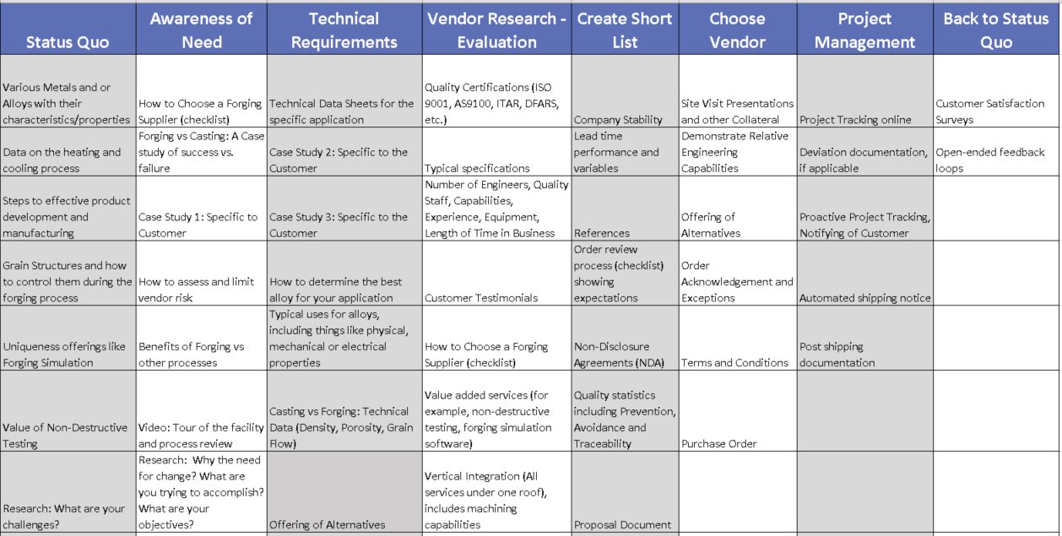

**Content Marketing Framework Template**

**x**

**x**

**x**

**x**

**x**

**x**

**x**

**x**

**Content Marketing Framework Template**

**x**

**x**

**x**

**x**

**x**

**x**

**x**

**x**